**Fluorescence Correlation Spectroscopy (FCS)**

**Homework TD**

1. **Scientific paper Review.**

**From Paper study**:

1- Sample Preparation: write precise protocol for sample preparation (growth media, OD, Immobilization,…)

2- Data Acquisition: Write data acquisition protocol (laser wavelength, power, size image, dwell time, # image,…)

1. **Data analysis simulation with PaTrack software:**

* Load Test tif files (m_04-920 nm_6mW_40 usec_50 frames_Ch2
* Follow the instructions.

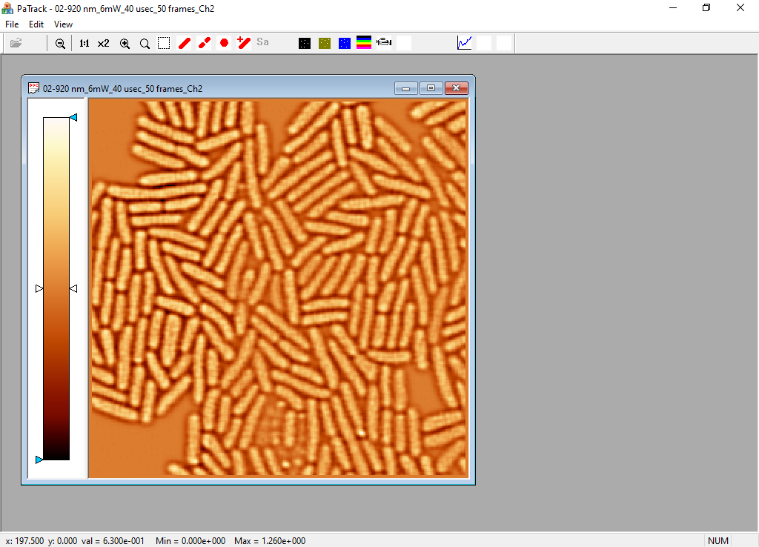

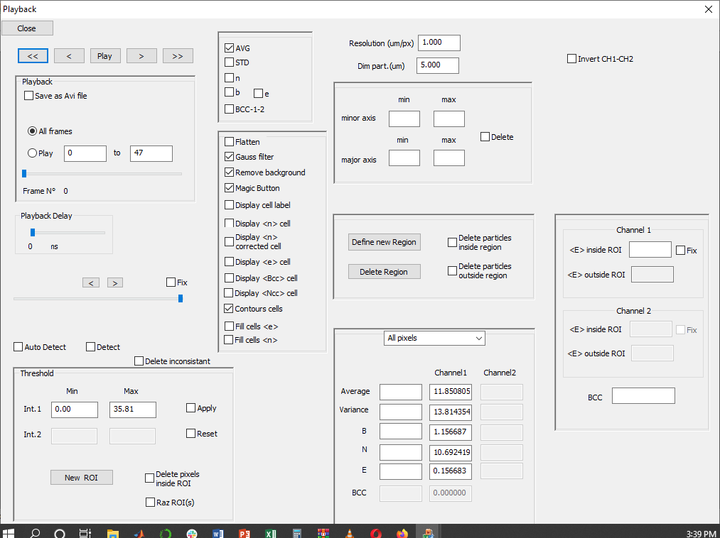

Detect all the cell

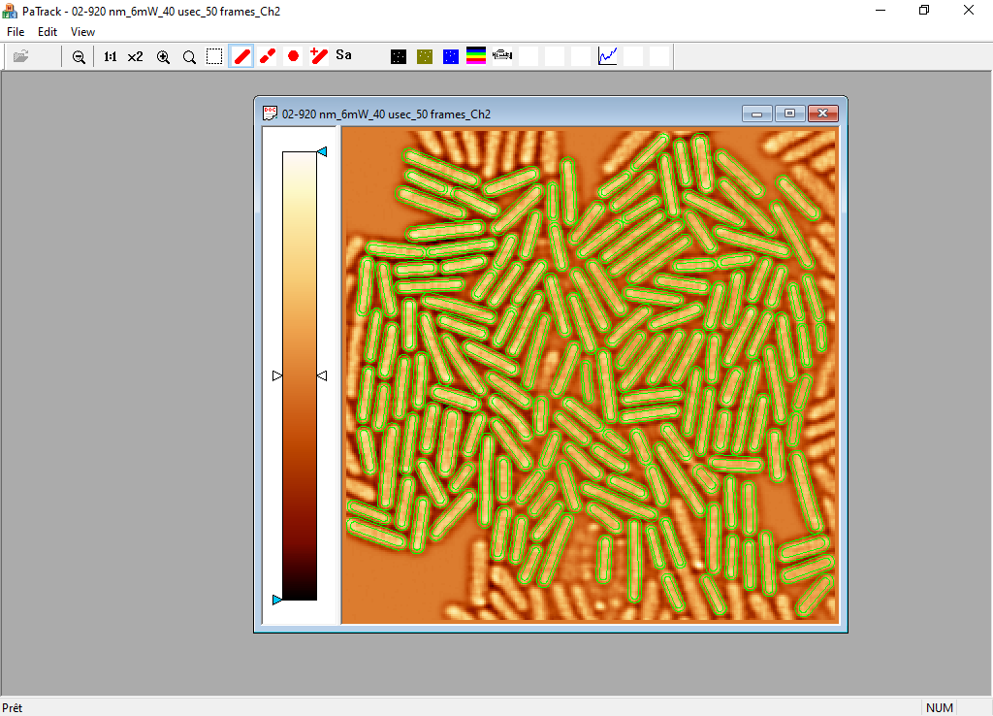

Save data

Right click to delete inconsistent cell, separate, delete, ect….

Once you’re done with cell selection, save your data.

A .spe file will be saved.

Open .spe file in bloc-notes

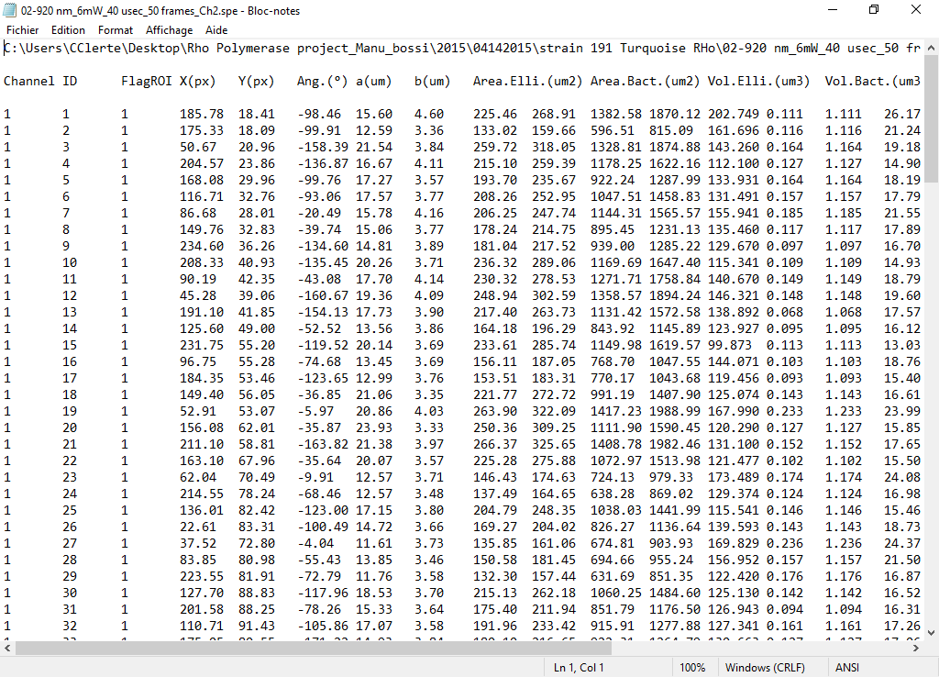

Copy and paste n, e, B and <F> data in excel

* Then proceed with file Rho_02-920 nm_6mW_40 usec_50 frames_Ch2) in PaTrack.
* Calculate the average true brightness e (or ) for both set of data.
* Discuss and Comment the results obtained.
* If Fluorescence intensity background is = 1; Calculate the corrected brightness and the corrected Number of molecule/cell.
* Think about and Write a script to calculate the absolute Number of Molecule/cell from N&B data that you’ll collect during the practical.

1. **Diffusion Coefficient Calculus Exercises.**

* Calculate theoretical Diffusion Coefficient for Alexa488 and GFP in Water.
* Look for in biblio a experimental measured Diffusion Coefficient of EGF in Cytoplasm (either Eukaryote or Prokaryote). Calculate the apparent crowdedness of the cytoplasm.
* Write autocorrelation function as function of W0, Z0,  and D. What happens when =D
* Calculate the diffusion Coefficient for a monomeric and a dimeric form of a protein (MW= 100KDa). If you have a perfect mixture of monomer and dimer in your tube, can you observe and quantify each species in a FCS autocorrelation experiment?

1. **Simulations Point FCS data using SimFCS software.**

**Exercise 1: Simulation of single species FCS.**

**1-1: Setting up the problem**

**1**_Open **SimFCS** (Fig. 1) (As administrator)

Fig 1

**2**_Select “**Simulate FCS data**” in the action panel at the left‐hand side of the screen (Fig 2).



**3**_Select “**Parameters**” from the menu at the top of the screen (Fig. 3).

**PSF**: This tab has the options for the shape of the point spread functions (Fig. 5)



**4**_Select “3**‐D Gaussian**” from the pull‐down menu.

**5**_ Set the **Radial Waist** (r or y) to **0.3** (the units are microns) and the **Axial Waist** to **1.5** μm

Ignore the value of ***Radial Waist (x***)—this refers only to point spread functions that are

not cylindrically symmetric

should be set to zero.

The ***plotting threshold*** is simply for visualization and will not affect the outcome of the

simulation.

**6**_Set the **box size** to **64**.

*This is actually the half size of the box. Since the simulation moves the particles in a random walk along a*

*grid of points spaced 0.05 μm apart, this will give a box with 6.4 um along each dimension.*

**7**_ Set the **multiple points** field to **1**.

Ignore the ***slit separation*** as this is for more complex simulations, as well as ***x,y,z for nonscanning***

and leave ***Perfect 0_9N.psf***

***Note that if you click the last line of this tab gives you the volume of the box and the size of the***

***PSF in*** ***m3***

**Particles**: This tab allows you to choose the numbers and types of particles for the simulation (Fig 6).

We will be doing a single species simulation, so only the first row will have particles.



**8**_ In column **“# mol”** column choose **100** molecules.

*Note: The* ***maximal number*** *of particles is* ***4000****.*

**9**_In column “**Br1 (cpsm)**” choose a brightness of **100,000** counts per second per molecule

(cpsm).

*This is the average intensity at the peak of the point spread function*.

**10**_ In column “**D (μm2/s)**” set the diffusion coefficient to **40** μm2/s.

*Note that at the bottom left hand corner of the tab, there is a Max D value in μm2/s. This maximum value is*

*set by the simulation based on the time per channel (clock frequency) which we will set later. This D value is the value*

*at which the probability of making two grid steps in one‐time step becomes significant. It is possible to set the*

*diffusion coefficient to a value higher than this, but the simulation will be physically unrealistic, because grid steps*

*greater than one are not allowed.*

Ignore the ***rotation value*** for now.

**11**_ Set “**Br2**” to **zero**.

*This is the brightness of the particle in the second channel. It is set to zero because we will only be simulating*

*one detection channel.*

The ***“Flow”*** column introduces a directional movement and will not be used in this exercise.

**12**_Select type “**1**” for normal particles in the seventh column “**1..6**”.

*At the bottom right of the table is a legend showing the type of particle that this last column can designate.*

*A “2” in this column indicates that the particle will rotate with a time constant equal to the value in the rotation*

*column, which is in units of time channels. A “3” and “4” in this column refer to different shapes of macromolecular*

*assemblies*, *like molecules on a stick (DNA) and molecules on a disk (rafts).*

**Misc**: This tab contains options for rotation, flow, background, and particle confinement (Fig. 7).



**13**_ Select “**randomize data**” and

**14**_ “**Use Poisson dist for counts**.”

*These settings are appropriate for simulating photon counting, not analog detection. For analog detection, on top of a*

*Poisson distribution there is an additional exponential distribution due to the process of electron multiplication in the*

*photomultiplier.*

**Time/scan:** This tab allows for the simulation of circular scanning, line scanning, camera scanning or

raster scanning FCS (Fig. 8).



**15**_Make sure the “**Scanning**” check box is **unchecked**.

**16**_Set the clock **frequency** to **100,000 counts/sec/particle. Note that in this simulation we are**

**using** 10 μs dwell time.

*The frequency is the inverse of the dwell time in* ***seconds***

**17**_ Set the “**Cycles**” field to **50**.

*One cycle is the amount of time required to collect 215 data points.*

*At the right‐hand side of the tab, the actual simulation time* ***(time(s)=)*** *is shown in seconds.*

The ***“Binning Mode,” “Use sections,”*** and ***“Number of bins for linear scale”*** fields are

for display during the simulation and will not affect the outcome.

The following tabs will be ignored for now:

**Stick/Disk:** This tab allows the simulator to change the shape and properties of the stick or disk

particles selected under the Particles tab.

**Reaction:** This tab allows for reactions (exchange of properties) between particles (rows) defined in the

Particles section. This allows to simulate bleaching, FRET or other chemical reactions.

**Display:** The tab allows for the change of the display during the simulation run. It does not affect the

simulation.

**TZone 2D:** The tab allows for parameters related to transient confinement of particles.

**Binding 2D:** Used to introduce sites of binding in the simulation

**Channel 2D:** Used to simulate diffusion/transport across a channel

**3D object:** Used for the simulation of 3D shapes.

**1-2: Running the Simulation:**

**18**_Click on “**Parameter**” (Fig. 9)



**19**_ Click on “**Start_simulation**” at the top of the simform window.

**20**_ Select “**Isotropic diffusion**” from the pull‐down menu.

*After a moment, the simulation will start.*

*If you like, select “Show PSF” (this will show a 3D threshold plot of the PSF). This can also be done before the*

*simulation to demonstrate the different PSFs. In addition, the particles can be plotted in real time (“Plot particles”*

*checkbox). All of these display options slow the simulation considerably, so it is advisable to turn them off for the*

*majority of the simulation.*

*Most plots in SimFCS can be modified by double clicking on the graph. The plotting routine is TeeChart Pro*

*and a free editor for Tee Chart Pro, Tee Chart Office, can be freely downloaded at:*

[*http://www.steema.com/download/other_projects*](http://www.steema.com/download/other_projects)*.*

*Also, during the simulation, the data will register on the main SimFCS screen (Fig. 9) similar to the way real*

*data acquisition would register. The top plot, an accordion plot, displays the intensity per second in red, and the G(0)*

*value of channel 1, estimated by the variance divided by the intensity squared, in green. On the bottom plot, the*

*logarithmically binned autocorrelation function is plotted. This function is calculated as the average of each cycle (215*

*points) and is calculated using the multiple tau approach. Note that this should only be used for visual purposes*

*during the simulation. After the simulation is complete, the “Recalculate” button (on the lower right of the screen) can*

*be pushed to get a more robust estimation of the autocorrelation function.*

**1-3: Analyzing the Data:**

**21**_Click “**Analysis**” under the main SimFCS screen, on the top menu (Fig. 10).



**22**_ Select “**Large vector correlation**” from the pull‐down menu.

A new window (**corrform**) opens (Fig. 11)*.*



*This section of the program calculates the autocorrelation function based on the* ***fast Fourier transform***

*(****FFT****). Since the FFT requires data to have a size that is a power of two, the autocorrelation function is calculated in*

*appropriately sized sections. In this example:*

**23**_ Select the entry **256K** (not 256!)).

**24**_ Select “**Plot each segment**” (screen bottom left), before starting the calculation to view

these segments as they are calculated.

**25**_ Press the “**calculate**” button to begin the calculations.

*The individual autocorrelation segments can be deleted. This capability is extremely useful in deleting, for*

*example, a section of the data that contains a spike, often due to a diffusing aggregate.*

*To delete an anomalous autocorrelation segment:*

***‐Click on it when it will appear red****.*

***‐Press “Delete segment****”, then*

*‐****Press “Recalculate average”*** *to recalculate the autocorrelation average without the (offending)*

*segment*

*Note that the errors are also calculated and can be visualized by selecting “Plot errors.” When the data are*

*saved (“Save correlation files”), the errors are saved as well. They can then be used as weighting factors for*

*fitting.*

*At the end of the calculation, the average is shown on the top graph (may be difficult to see if you are*

*plotting each segment). The bottom graph shows the logarithmically binned data. This format is generally*

*accepted for FCS data. On the right‐hand side of the page is the photon count histogram (PCH) and its*

*average.*

**26**_Select the “**fit**” tab on top of the corrform window (Fig.12).



The “**corrfit**” window will pop up (Fig. 13).



**27**_Input the values for the **waist=0.3** (in micron)

**28**_ **Deselect 2‐photon formulas**.

**29**_ **Initialize** the fit by extrapolating the value of **G(0) from the graph**.

*This step is not necessary, but it is important that the initial value of G(0) is different from zero.*

**30**_Select “**use weights**”

**31**_ Set “**Fix Bkgd**” **unchecked**.

*This will allow the background to vary.*

**32**_ Click on “**perform fit**”.

**QUESTION form exercise 1:**

* Calculate the concentration of particle in the simulation box (1m3 = 1fL= 10-15L)
* If you change beam waist or any other simulation parameter (diffusion, concentration, brightness, sample frequency). Comment your observations.
* Fit autocorrelation function obtained in the simulation to different radial waist. Comment results obtained.
* Fit autocorrelation function to different waist ratios (w0/wz). Comment on the sensitivity of FCS to the z dimension.

**Exercise 2: Simulation of 2 species.**

**2-1: Setting up the problem:**

For the formation of a dimer, the brightness and volume might both be expected to double. The

diffusion coefficient is inversely proportional to the cube root of the particle volume (the particle

radius), so it will be multiplied by a factor of (0.51/3 = 0.794), or approximately 32 μm2/s, if 40μm2/s is

the diffusion coefficient of the monomer.

Set up the simulation as we did in exercise 1 (steps 1 to 7), except for the particles section.

**1**_Open **SimFCS** (Fig. 1)

**2**_Select “**Simulate FCS data**” in the action panel at the left had side of the screen (Fig 2).

**3**_Select “**Parameters**” from the menu at the top of the screen (Fig. 3).

**4**_Select “ **3‐D Gaussian**” from the pull down menu (Fig. 5).

**5**_ Set the **Radial Waist** (r or y) to **0.3** (the units are microns) and the **Axial Waist** to **1.5** μm(Fig.

5) .

**6**_Set the **box size** to **64** (Fig. 5) .

**7**_ Set the **multiple points** field to **1** (Fig. 5) .

In the particles section (Fig. 15):

**35**_ Set the **number of particles** at **75** (mol#) with a **brightness** of **100,000** cpsm (Br1 cpsm)

**36**_ Set **25** particles at **200,000** cpsm.

**37**_Set the **diffusion** at **20** and **100** (D (μm2/s))



**2-2: Running the Simulation:**

Run the simulation following Steps 18 to 20 of exercise 1 (Fig. 9).

**18**_Click on “**Parameter**”.

**19**_Click on “**Start_simulation**” at the top of the simform window.

**20**_ Select “**Isotropic diffusion**” from the pull‐down menu

**2-3: Analyzing the Data (SimFCS):**

Repeat steps 21‐32 of exercise 1 (Figs. 10 to 13)

**21**_Click “**Analysis**” under the main SimFCS screen, on the top menu (Fig. 10).

**22**_ Select “**Large vector correlation**” from the pull‐down menu (Fig. 10).

**23**_ Select **256K** (not 256!)) (Fig. 11).

**24**_Select “**Plot each segment**” (screen bottom left), before starting the calculation to view

these segments as they are calculated (Fig. 11).

**25**_ Press the “**calculate**” button to begin the calculations (Fig. 11).

**26**_Select the “**fit**” tab on top of the corrform window (Fig.12).

**27**_Input the values for the **waist=0.3** (Fig. 13)

**28**_ **Deselect 2‐photon formulas**. (Fig.13)

**29**_ **Initialize** the fit by extrapolating the value of **G(0) from the graph** (Fig. 13).

**30**_Select “**use weights**” (Fig.13).

**31**_ Set “**Fix Bkgd**” **unchecked** (Fig.13).

**32**_ Click on “**perform fit**” (Fig.13).

To fit the PCH data:

**38**_ Select on the upper left corner on the down arrow menu and switch from “autocorrelation

1” to “PCH 1”.

**39**_ Initialize the values for N and epsilon and leave N1, epsilon 1 and N2, epsilon 2 unchecked

to allow the two species to vary.



**QUESTIONS FOR EXCERCIES 2:**

* Calculate the concentration and diffusion of each species.
* If you change beam waist and or any others parameters (diffusion Coefficients- concentration-Brightness-Sample frequency,…) Comment your observations.

**Exercise 3. Simulation of two‐color experiments: cross‐correlation analysis of heterodimer formation**

**3-1: Setting up the problem:**

**40_**Set up the simulation with three types of particles as seen in Fig 17 (arrows).



*Here we have entries under Br2 which refers to the brightness in channel 2.*

*The first two particles are our monomeric species, one with brightness in channel 1 and the other*

*in channel 2. They happen to both have the same diffusion coefficient, so the simulation is*

*essentially the same as for Exercise 2.*

*The third species is the heterodimer, consequently, have brightness in both channels.*

**3-2: Running the Simulation:**

Run the simulation following Steps 18 to 20 of exercise 1 (Fig. 9).

**18**_Click on “**Parameter**”.

**19**_Click on “**Start_simulation**” at the top of the simform window.

**20**_ Select “**Isotropic diffusion**” from the pull‐down menu

**3-3: Analyzing the Data (SimFCS):**

We are going to analyze the data in three different ways:

Autocorrelation in channel 1.

Autocorrelation in channel 2.

Cross‐correlation between channel 1 and 2.

***3-4: Autocorrelation in Channel 1.***

Repeat steps 21‐44 of exercise 1 (Figs. 10 to 14)

**21**_Click “**Analysis**” under the main SimFCS screen, on the top menu (Fig. 10).

**22**_ Select “**Large vector correlation**” from the pull‐down menu (Fig. 10).

**23**_ Select **256K** (not 256!)) (Fig. 11).

**24**_Select “**Plot each segment**” (screen bottom left), before starting the calculation to view

these segments as they are calculated (Fig. 11).

Under the large vector correlation screen, you will notice that at the upper left of the dialog,

there is a set of radio buttons grouped under “function”. In the previous exercise we had “Ch1

autocorrelation” checked (Fig.18).



**25**_ Press the “**calculate**” button to begin the calculations (Fig. 11).

**26**_Select the “**fit**” tab on top of the corrform window (Fig.12).

**27**_Input the values for the **waist=0.3** (Fig. 13)

**28**_ **Deselect 2‐photon formulas**. (Fig.13)

**29**_ **Initialize** the fit by extrapolating the value of **G(0) from the graph** (Fig. 13).

**30**_Select “**use weights**” (Fig.13).

**31**_ Set “**Fix Bkgd**” **unchecked** (Fig.13).

*14th LFD Workshop in Advanced Fluorescence Imaging and Dynamics* 24

**32**_ Click on “**perform fit**” (Fig.13).

To fit the PCH data:

**33**_Click on the upper left corner on the down arrow menu and switch from “autocorrelation 1”

to “PCH 1” (Fig.14).

**34**_ Click on “**perform fit**” (Fig.14).

Results are shown in Fig. 19.



***Autocorrelation in Channel 2.***

Select “Ch2 autocorrelation” and do that analysis the same way as Ch1.

**Note:** Do not forget to properly **initialize** the fit by extrapolating the value of **G(0) from the graph.**



*The autocorrelation for channel 2 should appear in blue in the bottom graph (Fig. 20). The information*

*in the upper graph is overwritten when a new analysis is done, so make sure that you delete any outliers*

*and recalculate the average before analyzing a new channel.*

***Cross‐correlation between channel 1 and 2***

Now select “Ch1‐Ch2 cross‐corr” and perform the analysis.

**Note:** Do not forget to properly **initialize** the fit by extrapolating the value of **G(0) from the graph.**



*The cross‐correlation will appear in green along with the two autocorrelations (Fig. 21).*

*You can also do the “Ch2‐Ch1 cross‐corr” if you like, but the result will be the same and the Ch1 Ch2 data*

*will be overwritten. Also, only one cross correlation can be saved at a time.*

*The cross‐correlation is only sensitive to species that diffuse together in both channels, so you can fit the*

*data to a Gaussian single species model as in Exercise 1.*

**QUESTIONS FOR EXCERCIES 3:**

* If you change beam waist and or any others parameters (diffusion Coefficients- concentration-Brightness-Sample frequency,…) Comment your observations.







